Multilevel Truncated Negative Binomial Model Results

Fixed Effects Coefficients
Estimate | Std. Error | z value | P-value | Variable
-1.5411 | 2.3560 | -0.6541 | 0.5130 | (Intercept)
-0.0020 | 0.0037 | -0.5476 | 0.5839 | import_from_slu_log
0.0058 | 0.0001 | 47.2777 | 0.0000 | age
-0.0043 | 0.0042 | -1.0050 | 0.3149 | immigrant_density_centered
0.2756 | 0.2149 | 1.2824 | 0.1997 | state_percapita_income_log
0.0052 | 0.0051 | 1.0115 | 0.3118 | immigrant_similar
0.0006 | 0.0043 | 0.1477 | 0.8826 | immigrant_moderate
0.0104 | 0.0035 | 2.9438 | 0.0032 | sex_enc1
0.0040 | 0.0121 | 0.3307 | 0.7409 | marital_status_enc1
0.0040 | 0.0043 | 0.9432 | 0.3456 | marital_status_enc2
-0.0467 | 0.0283 | -1.6496 | 0.0990 | employment_status_enc1
0.1081 | 0.0202 | 5.3383 | 0.0000 | employment_status_enc2
0.1907 | 0.0198 | 9.6462 | 0.0000 | purpose_simple1
0.4483 | 0.0158 | 28.4439 | 0.0000 | purpose_simple2
0.1452 | 0.0136 | 10.6425 | 0.0000 | purpose_simple3
0.0079 | 0.0159 | 0.4949 | 0.6207 | purpose_simple4
0.1306 | 0.0092 | 14.1977 | 0.0000 | accomd_type_enc1
0.2359 | 0.0053 | 44.6193 | 0.0000 | accomd_type_enc2

Incident Rate Ratios (IRR) for Fixed Effects
Incident Rate Ratios for Fixed Effects
Variable | IRR | Lower CI | Upper CI | P-value
(Intercept) | 0.2141 | 0.0021 | 21.6846 | 0.5130
import_from_slu_log | 0.9980 | 0.9907 | 1.0053 | 0.5839
age | 1.0058 | 1.0056 | 1.0061 | 0.0000
immigrant_density_centered | 0.9958 | 0.9875 | 1.0041 | 0.3149
state_percapita_income_log | 1.3173 | 0.8645 | 2.0074 | 0.1997
immigrant_similar | 1.0052 | 0.9952 | 1.0152 | 0.3118
immigrant_moderate | 1.0006 | 0.9922 | 1.0092 | 0.8826
sex_enc1 | 1.0105 | 1.0035 | 1.0175 | 0.0032
marital_status_enc1 | 1.0040 | 0.9805 | 1.0281 | 0.7409
marital_status_enc2 | 1.0040 | 0.9957 | 1.0124 | 0.3456
employment_status_enc1 | 0.9543 | 0.9028 | 1.0088 | 0.0990
employment_status_enc2 | 1.1142 | 1.0708 | 1.1593 | 0.0000
purpose_simple1 | 1.2101 | 1.1641 | 1.2579 | 0.0000
purpose_simple2 | 1.5656 | 1.5180 | 1.6147 | 0.0000
purpose_simple3 | 1.1563 | 1.1258 | 1.1877 | 0.0000
purpose_simple4 | 1.0079 | 0.9769 | 1.0398 | 0.6207
accomd_type_enc1 | 1.1395 | 1.1191 | 1.1602 | 0.0000
accomd_type_enc2 | 1.2661 | 1.2530 | 1.2793 | 0.0000

Random Effects Variance Components
No random effect variance estimated for us_state_enc.

Model R-squared (Marginal and Conditional)
Statistic | Value
R2_conditional | 0.1116
R2_marginal | 0.0723

Variance Inflation Factor (VIF)
VIF Values (Note: VIF > 5 may indicate multicollinearity)
Variable | VIF
Predictor 1 | 1.44
Predictor 2 | 1.11
Predictor 3 | 34.31
Predictor 4 | 1.41
Predictor 5 | 3.07
Predictor 6 | 30.35
Predictor 7 | 1.02
Predictor 8 | 1.17
Predictor 9 | 1.00
Predictor 10 | 1.17
Predictor 11 | 1.15

Model Comparison (Truncated vs Non-truncated)
ANOVA Model Comparison Results
Df | AIC | BIC | logLik | deviance | Chisq | Chi Df | Pr(>Chisq)
20 | 746,000.3 | 746,197.2 | -372,980.2 | 745,960.3
20 | 751,682.9 | 751,879.8 | -375,821.4 | 751,642.9 | 0 | 0 | 1

Model Fit Statistics
Statistic | Value
AIC | 746,000.3
BIC | 746,197.2
Log-likelihood | -372,980.2

Robustness Checks

Robustness Check 1: Purpose of Visit × Immigrant Density
This model tests whether the effect of immigrant density varies by tourist purpose.
If immigrant networks matter, we would expect different effects for leisure vs business travelers.
Purpose × Immigrant Density Interaction Effects
Interaction Term | IRR | Lower CI | Upper CI | P-value
purpose_0_x_immigrant | 0.9977 | 0.9958 | 0.9996 | 0.0154
purpose_2_x_immigrant | 0.9975 | 0.9961 | 0.9989 | 0.0005
purpose_3_x_immigrant | 0.9979 | 0.9967 | 0.9991 | 0.0008
purpose_4_x_immigrant | 0.9967 | 0.9952 | 0.9982 | 0.0000
purpose_1_x_immigrant | NA | NA | NA | NA

Model Fit Statistics
Statistic | Value
AIC
BIC
Log-likelihood

Robustness Check 2: Accommodation Type × Immigrant Density
This model tests whether the effect of immigrant density varies by accommodation type.
Tourists staying with friends/relatives might benefit more from immigrant networks than hotel guests.
Accommodation Type × Immigrant Density Interaction Effects
Interaction Term | IRR | Lower CI | Upper CI | P-value
accomd_0_x_immigrant | 0.9995 | 0.9985 | 1.0005 | 0.3491
accomd_2_x_immigrant | 1.0021 | 1.0010 | 1.0032 | 0.0002
accomd_1_x_immigrant | NA | NA | NA | NA

Model Fit Statistics
Statistic | Value
AIC | 746,045.7
BIC | 746,695.4
Log-likelihood | -372,956.8

Interpretation of Robustness Checks
Non-significant interaction terms across both robustness checks would indicate that
immigrant density effects (or lack thereof) are consistent across tourist purposes and
accommodation types. This supports the interpretation that climate similarity, rather than
immigrant networks, drives the observed patterns in tourist behavior.

Main Model Diagnostics

Predicted vs Observed Length of Stay
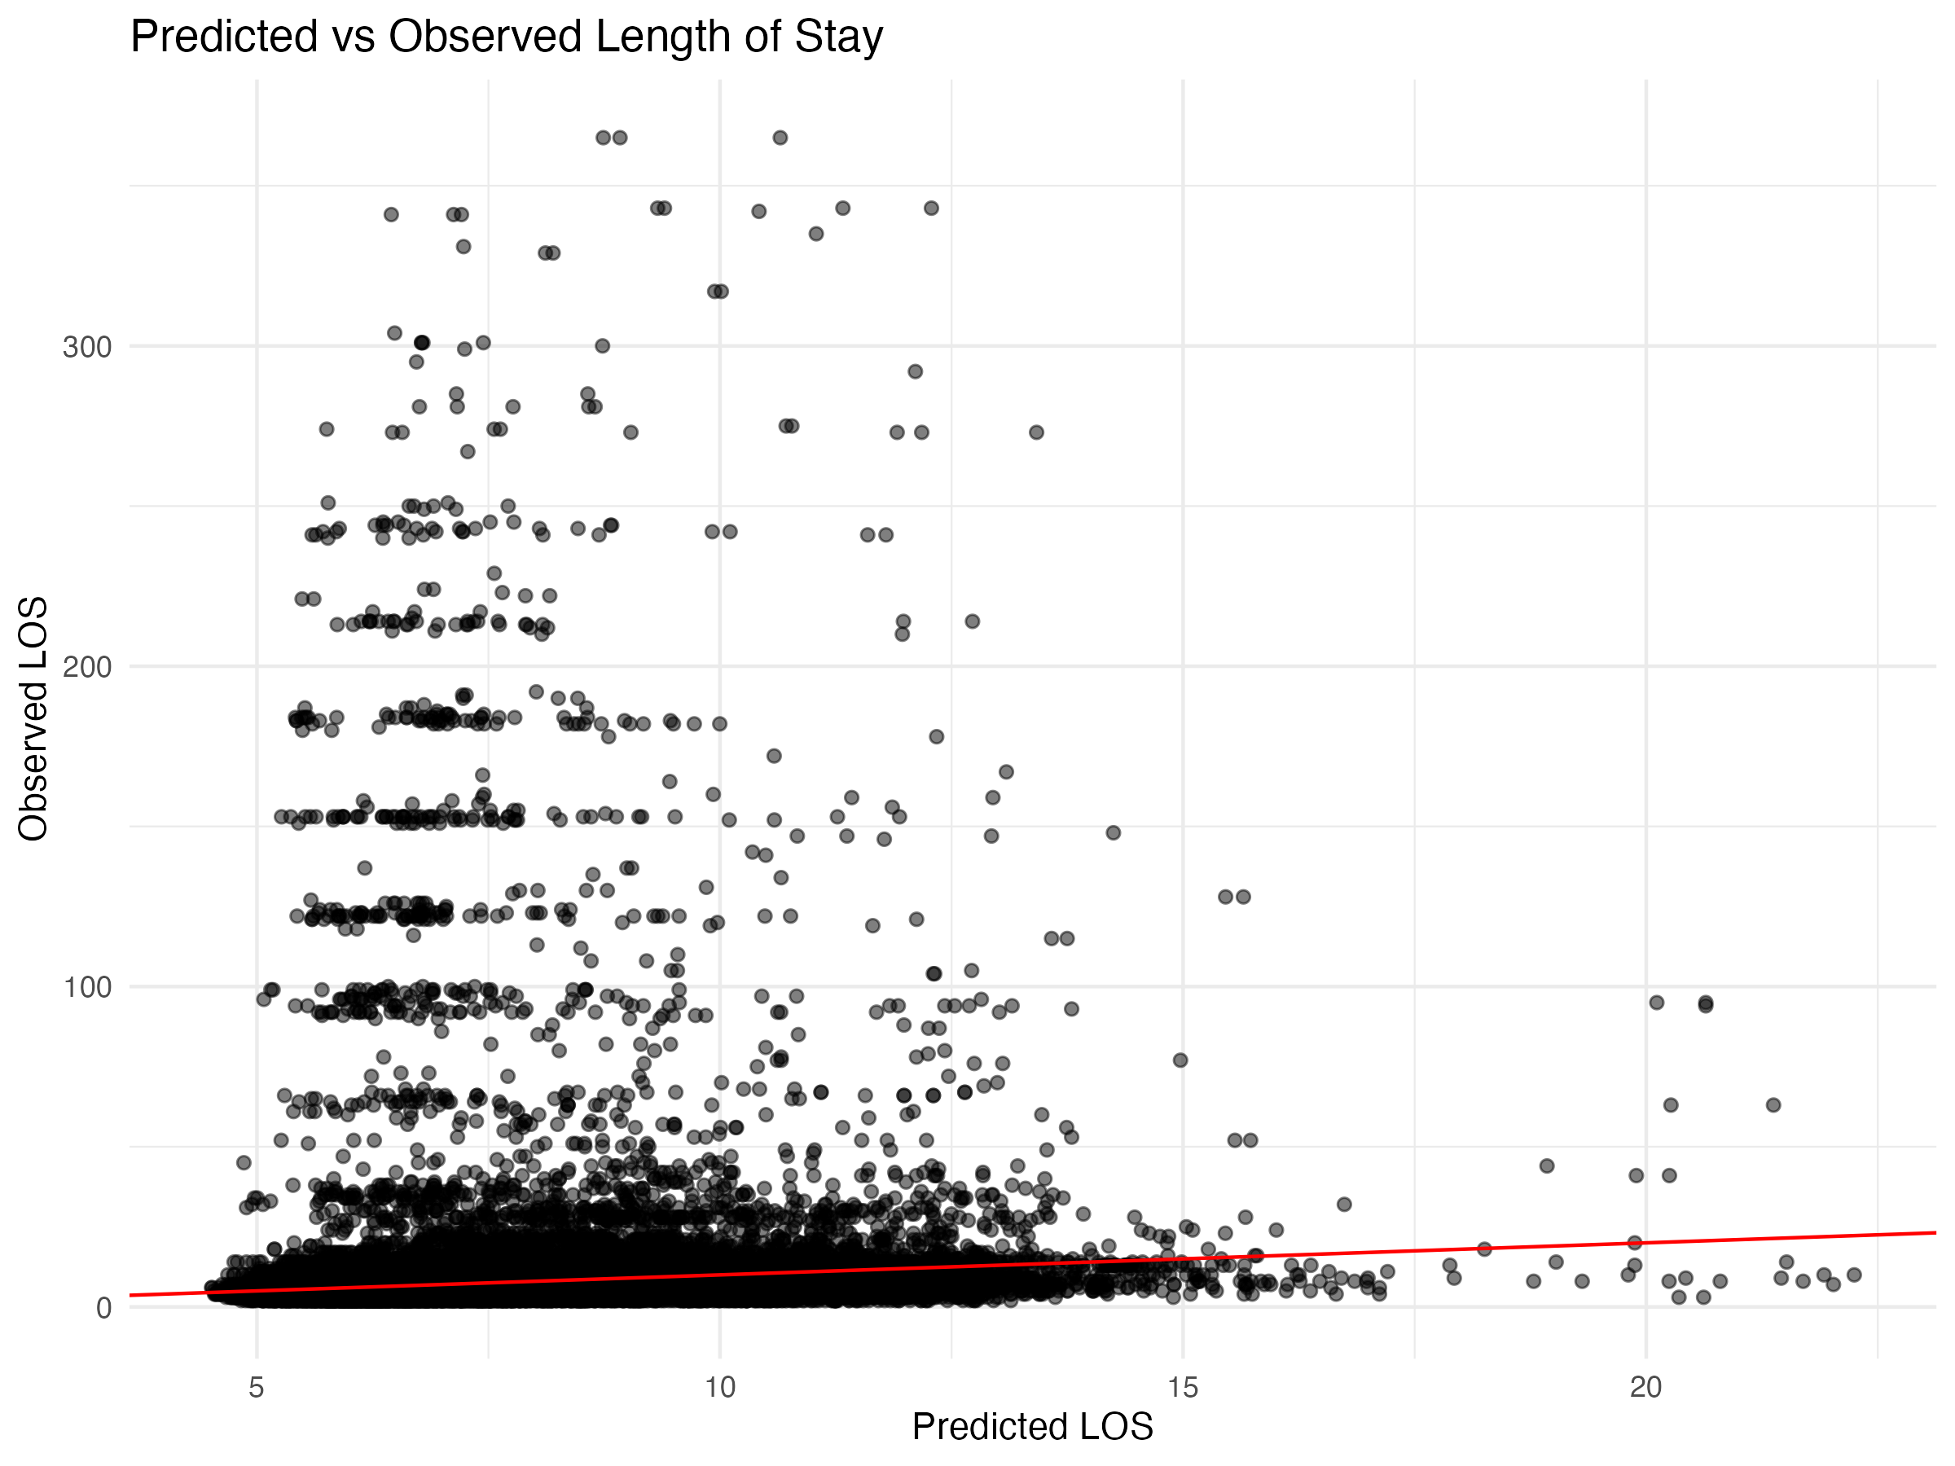

Diagnostic Plots

DHARMa Residuals
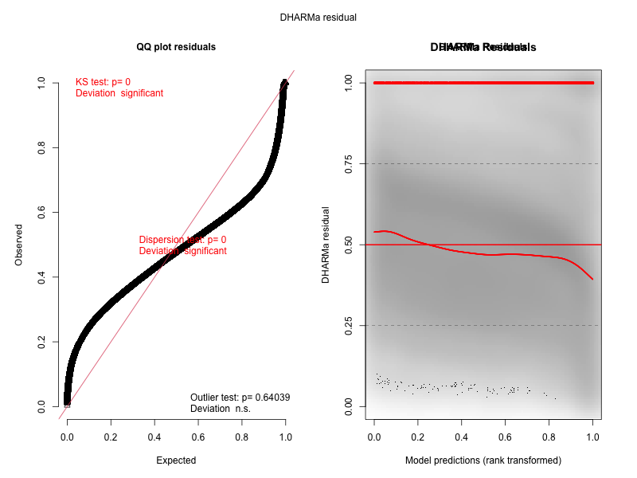

Residuals by State
